MOCKITO EXERCISES
1.Mocking And Stubbing
ExternalApi.java
package org.example;
public interface ExternalApi {
String getData();
}
MyService.java
package org.example;
public class MyService {
private ExternalApi externalApi;
public MyService(ExternalApi externalApi) {
this.externalApi = externalApi;
}
public String fetchData() {
return externalApi.getData();
}
}
MyServiceTest.java
import static org.junit.jupiter.api.Assertions.assertEquals;
import static org.mockito.Mockito.*;
import org.junit.jupiter.api.Test;
import org.mockito.Mockito;
import org.example.ExternalApi;
import org.example.MyService;

public class MyServiceTest {

@Test
public void testExternalApi() {
// Step 1: Create a mock object
ExternalApi mockApi = Mockito.mock(ExternalApi.class);
// Step 2: Stub the method to return predefined value
when(mockApi.getData()).thenReturn("Mock Data");
// Step 3: Write test case using mock object
MyService service = new MyService(mockApi);
String result = service.fetchData();
assertEquals("Mock Data", result);
}
}

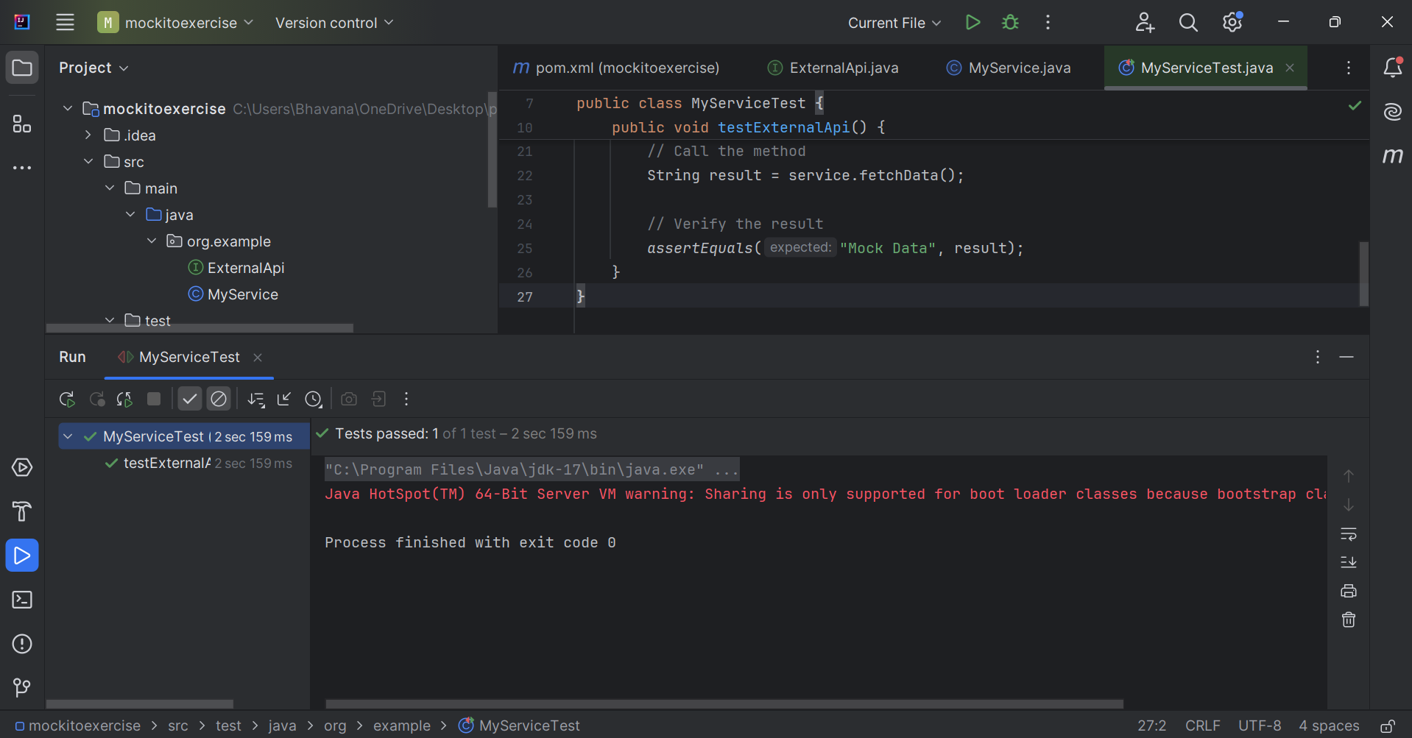

2.Verifying Interactions
ExternalApi.java
package org.example;
public interface ExternalApi {
String getData();
}
MyService.java
package org.example;
public class MyService {
private ExternalApi externalApi;
public MyService(ExternalApi externalApi) {
this.externalApi = externalApi;
}
public String fetchData() {
return externalApi.getData();
}
}
MyServiceTest.java
import static org.mockito.Mockito.*;
import org.junit.jupiter.api.Test;
import org.mockito.Mockito;
import org.example.ExternalApi;
import org.example.MyService;
public class MyServiceTest {
@Test
public void testVerifyInteraction() {

// Step 1: Create a mock object
ExternalApi mockApi = Mockito.mock(ExternalApi.class);

// Step 2: Call the method
MyService service = new MyService(mockApi);
service.fetchData();

// Step 3: Verify the interaction
verify(mockApi).getData();
}
}

